A

PROJECT REPORT

ON

“<<AIRBOOK VILLA>>”

SUBMITTED TO

SHIVAJI UNIVERSITY, KOLHAPUR

IN THE PARTIAL FULFILLMENT OF THE REQUIREMENT
FOR THE AWARD OF DEGREE
BACHELOR OF TECHNOLOGY IN COMPUTER SCIENCE AND ENGINEERING

SUBMITTED BY

MISS. | PRACHI ASHOK KUNNURE | 22UAD033

UNDER THE GUIDANCE OF

Mr. S. P. Pise
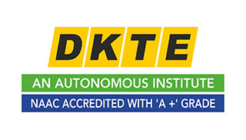


DEPARTMENT OF ARTIFICIAL INTELLIGENCE AND DATA SCIENCE ENGINEERING
DKTE SOCIETY’S TEXTILE AND ENGINEERING INSTITUTE, ICHALKARANJI
(AN EMPOWERED AUTONOUMOUS INSTITUTE)
2024-2025

D.K.T.E. SOCIETY’S

TEXTILE AND ENGINEERING INSTITUTE, ICHALKARANJI
(AN EMPOWERED AUTONOUMOUS INSTITUTE)

DEPARTMENT OF ARTIFICIAL INTELLIGENCE AND DATA SCIENCE ENGINEERING



CERTIFICATE

This is to certify that, project work entitled

“<<AIRBOOK VILLA>>”

is a bonafide record of project work carried out in this college by

MISS. | <<PRACHI ASHOK KUNNURE >> | << 22UAD033>>

is in the partial fulfillment of award of degree Bachelor of Technology in Artificial Intelligence and Data Science Engineering prescribed by Shivaji University, Kolhapur for the academic year 2024-2025.

MR. S. P. PISE
(PROJECT GUIDE)

PROF. (DR.) T. I. BAGBAN PROF.(DR.) L.S.ADMUTHE
(HOD AI & DS DEPT.) (DIRECTOR)

EXAMINER: ________________
DECLARATION

We hereby declare that, the project work report entitled “<<project title>>” which is being submitted to D.K.T.E. Society’s Textile and Engineering Institute Ichalkaranji, affiliated to Shivaji University, Kolhapur is in partial fulfillment of degree B.Tech.(AI & DS). It is a bonafide report of the work carried out by us. The material contained in this report has not been submitted to any university or institution for the award of any degree. Further, we declare that we have not violated any of the provisions under Copyright and Piracy / Cyber / IPR Act amended from time to time.

Title | Name of the Student | PRN | Signature
MISS. | <<PRACHI ASHOK KUNNURE >> | <<22UAD033 >> | << >>

ACKNOWLEDGEMENT

With great pleasure we wish to express our deep sense of gratitude to Mr. S. P. Pise for his valuable guidance, support, and encouragement in the completion of this project report.
Also, we would like to take the opportunity to thank our head of department Dr. T. I. Bagban for his cooperation in preparing this project report.
We feel gratified to record our cordial thanks to other staff members of the Artificial Intelligence and Data Science Department for their support, help, and assistance which they extended as and when required.

Thank you,
Title | Name of the Student | PRN
MISS. | PRACHI ASHOK KUNNURE | 22UAD033
ABSTRACT
This project is a web-based application developed using the MERN (MongoDB, Express.js, React, Node.js) stack. The platform is designed to facilitate the seamless management of villaproperties, focusing on CRUD (Create, Read, Update, Delete) operations and user authentication. The core functionality ensures that registered users who sign up or log in have exclusive rights to edit and delete villa listings, thereby maintaining the integrity and security of the platform. Moreover, the system empowers users to provide reviews on villa listings,fostering a transparent and engaging environment for prospective tenants.
Key features include:
- User Authentication: Implementing secure sign-up and login mechanisms using JSON Web Tokens (JWT) and password encryption ensures that only authorized users can make changes to villa entries.
- CRUD Operations: Users can create new villa listings, view details, update information, and delete entries, supported by a robust backend connected to MongoDB for efficient data management.
- Review System: Enables users to provide ratings and reviews for villa properties, allowing other users to make informed decisions.
- Responsive Interface: The React-based front end offers a visually appealing and user-friendly interface optimized for devices of all sizes.
- API Integration: Node.js and Express.js facilitate API interactions for data retrieval, authentication, and CRUD functionalities.
- Role-Based Access: Role-based permissions ensure that villa management rights are restricted to authenticated users while review functionality is accessible to all registered users.
- Uploaded File: Images that has uploaded in the Files format are stored at cloud with clodinary .com.
- Database Storage: Overall data is stored on the cloud with MongoDb.com/atlas/database website
INDEX

- Introduction

  - Problem definition <<1 >>

  - Aim and objective of the project <<1>>

  - Scope and limitation of the project <<2>>

- Background study and literature overview <<2>>

  - Literature overview <<2 >>

  - Investigation of current project and related work <<3 >>
- Requirement analysis <<3 >>
a. Requirement Gathering <<4>>
b. Requirement Specification <<5>>
c. Use case Diagram <<6>>
- System design <<6>>

  - Architectural Design <<6 >>

  - Flow Chart <<6 >>

  - System Modeling <<6 >>

    - Dataflow Diagram <<6 >>
- Implementation <<7 >>

a. Agile Methodologies <<7 >>
b. Development Model <<7 >>
- Future Scope <<8>>

- References (Public repository GitHub source code links) <<9>
1. Introduction

Aim and Objective of the Project
Aim: Build an innovative platform that bridges the gap between villa owners and renters, allowing users to discover, book, and manage villa stays effortlessly.
Objectives:
- Empower villa owners to create detailed listings with high-quality images, pricing information, and unique selling points.
- Simplify the booking process for renters by introducing personalized search filters, date-based availability checks, and detailed villa information.
- Improve trust and transparency by integrating a rating and review system for both owners and renters.
- Provide robust user authentication and data security to protect sensitive information.
- Enhance scalability to accommodate growth and support more users and regions in the future.
Expanded Objectives:

- Introduce advanced features such as:
  - Location-based recommendations to suggest villas based on proximity to popular attractions or amenities.
- Facilitate secure communication between villa owners and renters via an in-app messaging system.

Scope and Limitation of the Project
Scope:
- Develop a platform where villa owners and renters can interact seamlessly to create and discover listings.
- Implement essential features such as:
  - Authentication and account management for users (renters and owners).
  - Interactive dashboards for villa owners to monitor bookings, track and manage property details.
- Integrate external services like Cloudinary for image storage
- Provide a responsive design to ensure usability on mobile, tablet, and desktop platforms.
Expanded Scope:
- Incorporate AI-powered personalization to offer tailored suggestions for renters .
- Support multiple languages and currencies to appeal to international travelers and villa owners.
- Include a feedback system to allow renters to leave reviews and rate villas and owners, helping to build trust within the platform.
- Extend functionalities with potential partnership programs to connect renters with additional services (e.g., transportation, catering, local activities).

- Limitations:
- Initial focus on villa accommodations, excluding other rental types such as apartments, guesthouses, or hotels.
- Dependence on owner input for real-time updates, which might create delays in availability information.
- Initial geographical restrictions for payment systems, potentially limiting operations to select regions or countries.
- Limited ability to verify the accuracy of owner-provided villa details and images during the early stages of platform development.
- Restricted features for offline use since the platform relies heavily on internet connectivity for bookings and updates.

2. Background Study and Literature Overview

- Literature Overview:

The concept of staycations has gained momentum globally, driven by the increasing preference for domestic travel and the convenience of quick getaways. Research highlights that travelers are seeking more personalized, private, and flexible accommodation options, such as villa rentals. The advent of digital platforms like Airbnb and Vrbo has revolutionized how users discover and book these properties. Studies emphasize the importance of showcasing property amenities, user reviews, and location details to build trust and enhance user experience.
Furthermore, trends in travel technology show a shift towards integrating AI-driven solutions, seamless navigation, and customization features to help users find properties that match their specific needs. By analyzing these advancements, your project can tap into proven strategies while offering innovative enhancements tailored to the staycation market.
b. Investigation of Current Project and Related Work
Existing platforms such as Airbnb, Booking.com, and niche villa-rental websites provide a range of options for users. However, gaps exist in terms of user-centricity, like limited filters for staycation-specific features (e.g
., private pools, pet-friendly villas, or proximity to nature). Many platforms also lack intuitive interfaces that cater exclusively to villa clients who wish to advertise their properties in a simplified way.
Airbook Villa aims to address these shortcomings by creating.

a dedicated platform focusing on:
- Transparent and detailed villa listings, including photos, descriptions, and real-time availability.
- User-friendly search options that prioritize personalization, such as budget filters, nearby attractions, and unique amenities.
- Seamless interaction between villa owners (clients) and potential renters, fostering trust and ease of communication.

3. Requirement analysis

- Requirement Gathering

Definition: Requirement gathering is the process of collecting and analyzing the needs and expectations of stakeholders (e.g., clients, users, and developers) for the project.
- Techniques:
  - Interviews: Conduct discussions with potential villa owners, renters, and stakeholders to understand their needs.
  - Surveys and Questionnaires: Gather inputs from users regarding features they'd like to see in the platform.
  - Observation: Study user behavior on existing platforms like Airbnb or Vrbo to identify pain points.
  - Brainstorming with Stakeholders: Collaborate with developers, designers, and users to define goals and features.
- Outcome:
  - A list of functional requirements (e.g., user signup, villa search, booking system).
  - A list of non-functional requirements (e.g., scalability, security, and performance).

b. Requirement Specification
Definition: Requirement specification involves documenting the gathered requirements into a structured format that serves as a reference for the development team.
- Functional Requirements:
  - User Authentication: Users can sign up, log in, and manage profiles.
  - Villa Listing Creation: Owners can add detailed listings with images, prices, and availability.
  - Search and Filter Functionality: Renters can find villas based on location, price, availability, and reviews.
  - Booking System: Users can book a villa, and availability is updated automatically.
  - Dashboard: Separate dashboards for owners (to manage listings) and renters (to track bookings).
- Non-Functional Requirements:
  - Performance: The platform should handle at least 10,000 users simultaneously without delays.
  - Security: User data and payment information should be encrypted.
  - Scalability: The system must accommodate future expansion for multiple regions and currencies.
- Outcome:
  - A detailed document (Software Requirement Specification - SRS) that includes user stories, mock-ups, and clear acceptance criteria.

Use Case Diagram
Definition: A use case diagram is a visual representation of the interactions between users (actors) and the system, showcasing the features of the platform.
- Actors:
  - Villa Owners: Create and manage villa listings, view bookings.
  - Renters (Passengers): Search, book villas, leave reviews.
  - Admin: Monitor platform activities, manage user accounts and content.
- Use Cases:
  - Authentication: Login and signup for both owners and renters.
  - Villa Management (Owner): Add, edit, or delete villa listings.

4. System design
Flowchart:

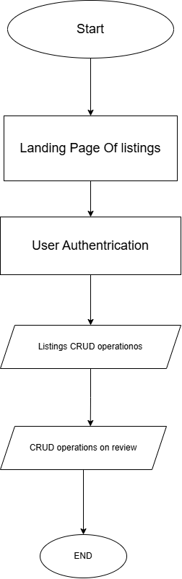
Architecture:

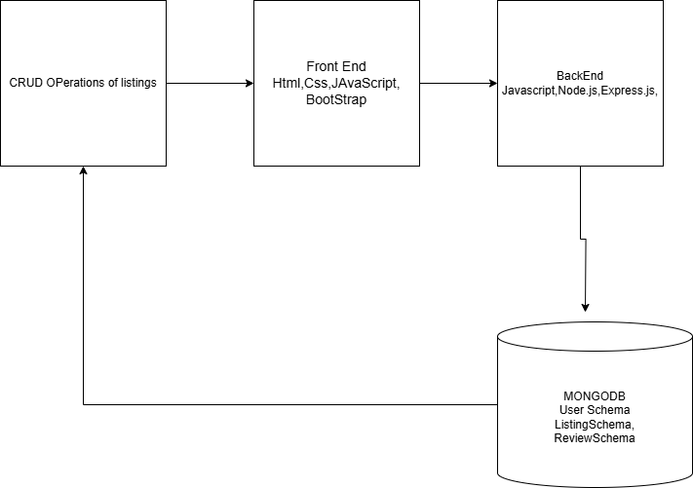
Data Flow Diagram:

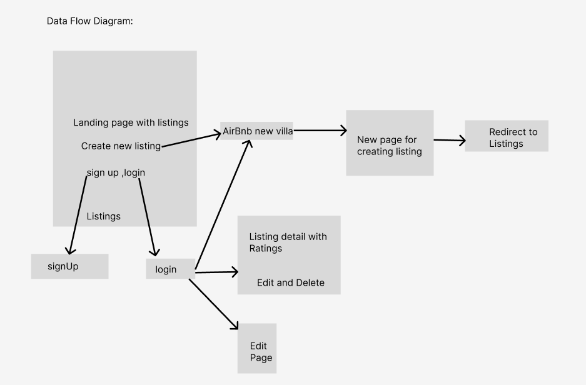

5.Implementation

a.Agile Methodologies:

Definition: Agile methodologies are an iterative and flexible approach to software development that emphasizes collaboration, adaptability, and delivering value quickly.
- Key Principles:
  - Incremental Development: Break the project into smaller tasks, called sprints, which deliver usable features at the end of each cycle.
  - Collaboration: Foster communication between developers, stakeholders, and users for continuous feedback.
  - Adaptability: Make iterative changes based on evolving requirements and user feedback.
- Benefits for Your Project:
  - Frequent user feedback ensures that features meet expectations.
  - The iterative approach allows you to add functionality progressively, such as authentication in one sprint and villa search in another.
  - Early delivery of core features lets stakeholders and users test the platform quickly.
- Agile Framework Examples:
  - Scrum: Focuses on short, defined sprints and daily standups for progress tracking.
  - Kanban: Visualizes tasks on a board, emphasizing continuous delivery.

b. Development Model

Definition: The development model refers to the approach used to design, implement, and deliver software efficiently. For your project, the Agile models pairs well with the MERN stack.
- Phases in the Agile Model:
  - Concept and Planning: Identify project requirements, user stories, and high-level goals.
  - Design and Prototyping: Create mock-ups for the villa listing and booking interfaces.
  - Development: Build core features in iterative sprints (e.g., authentication, villa listing, booking system).
  - Testing: Perform usability testing, database checks, and debugging after each sprint.
  - Delivery: Deploy usable versions incrementally while continuing to refine the platform.
- Agile vs. Traditional Models:
  - Unlike traditional models like the Waterfall Model, Agile allows flexibility in requirements. For instance, if users suggest adding location-based villa recommendations mid-project, Agile lets you incorporate the feature in future sprints without disrupting progress.
- Why Agile for Your Project:
  - Offers adaptability for continuously evolving needs in a dynamic system like villa rental.
  - Enhances responsiveness to user feedback, ensuring features are user-centric.
  - Enables quick delivery of essential features, such as villa search and booking, while scaling later.

6. Future Scope:

The future scope of villa rental platform is vast, as it can be expanded into a comprehensive solution that caters to both local and international audiences. Here are some potential avenues for
growth:
1. Advanced Search and Personalization:
- Implement AI-powered recommendations to provide personalized villa suggestions based on user preferences, booking history, and location trends.
- Introduce voice-enabled search options to enhance accessibility and user convenience.
2. Expansion of Rental Categories:
- Extend the platform to include other property types, such as apartments, hotels, or vacation homes, catering to diverse user needs.
- Introduce options for long-term stays or rentals for events and celebrations like weddings.
3. Globalization
- Support multi-currency payments and regional language interfaces to make the platform accessible to international users.
- Expand listings to cover properties in multiple countries, offering villa rentals worldwide.

7. References (public repository GitHub source code links)

Project Link :https://github.com/Prachikunnure/Mini-Project

RESOURCES:

- Unsplash.com: http: //unsplash.com/s/photos/villa%20images
- Cloudinary.com: http://cloudinary.com/
- MongoDb.com/Atlas/Database: https: //www.mongodb.com/products/platform/atlas-database
- Font Awesome: https://fontawesome.com/search
- Google fonts: google fonts.com

